Installing Android Studio and Sync with Github
- Install Android Studio Otter (Download Android Studio & App Tools - Android Developers)
  - Install standard installation (no custom needed)
  - After successful installation –
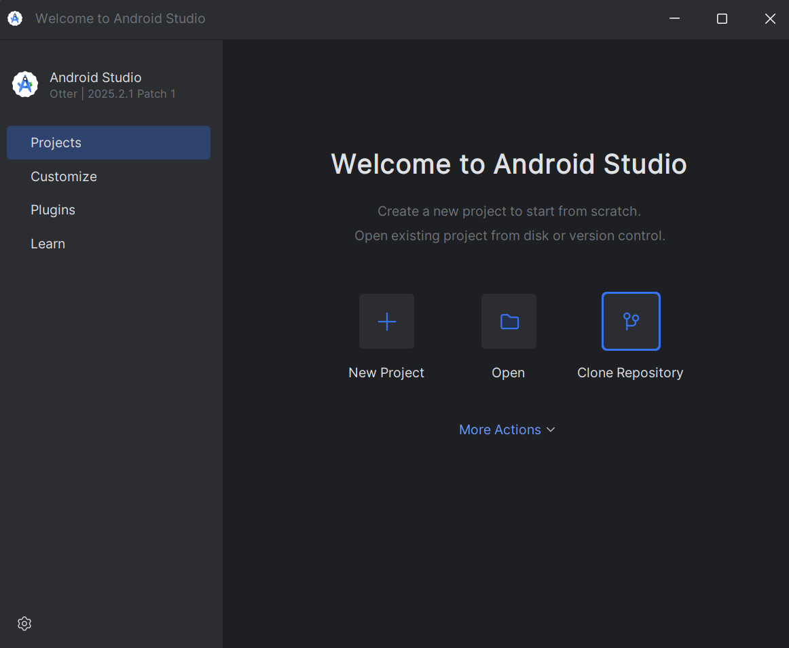
- Clone Repository
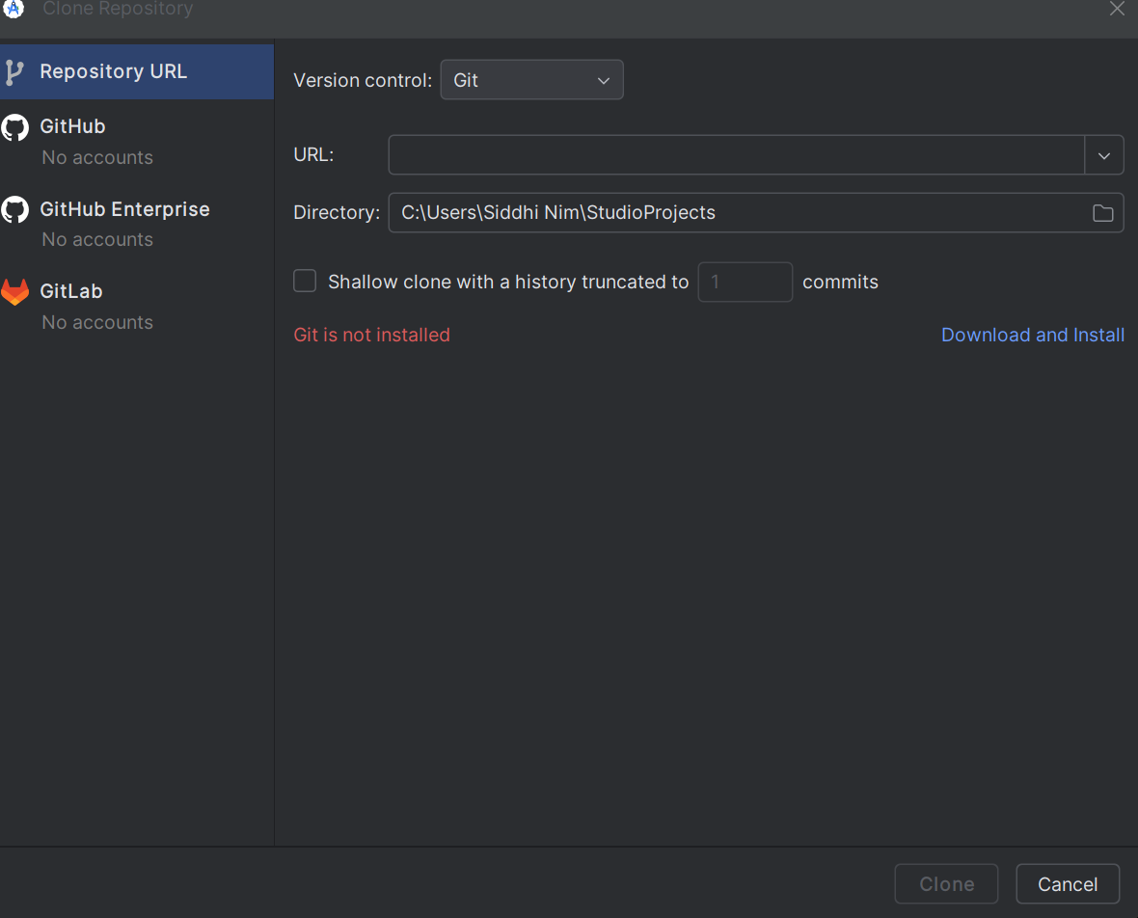
- Select github
- Login: astraftc@gmail.com Password: Home@10306
- Clone FtcRobotController_1126
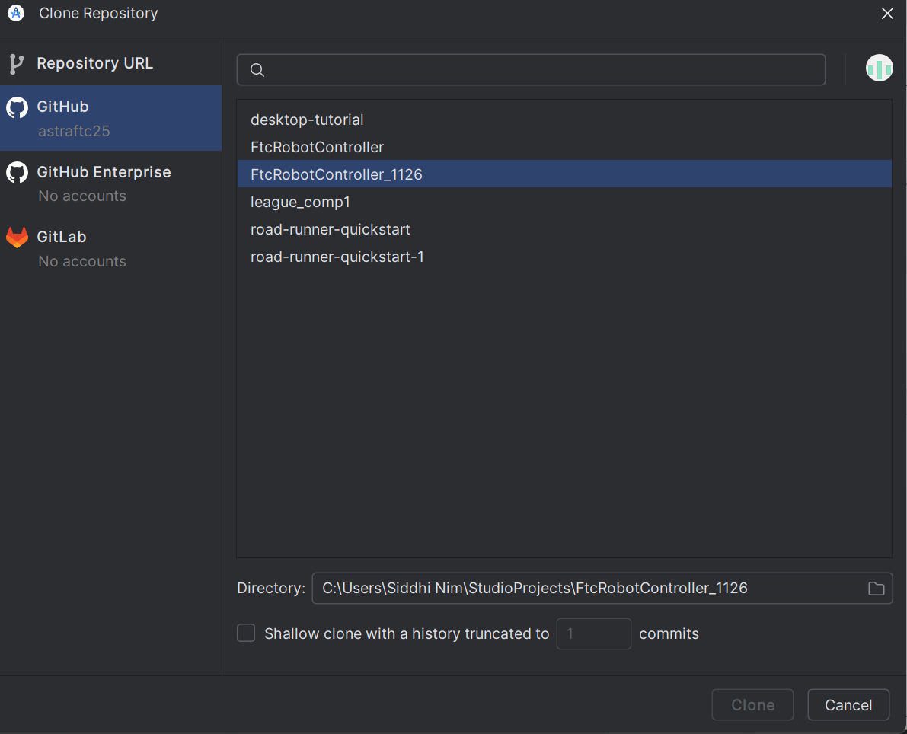
- Git tool was not installed on Windows PC, follow the instructions to download and install git
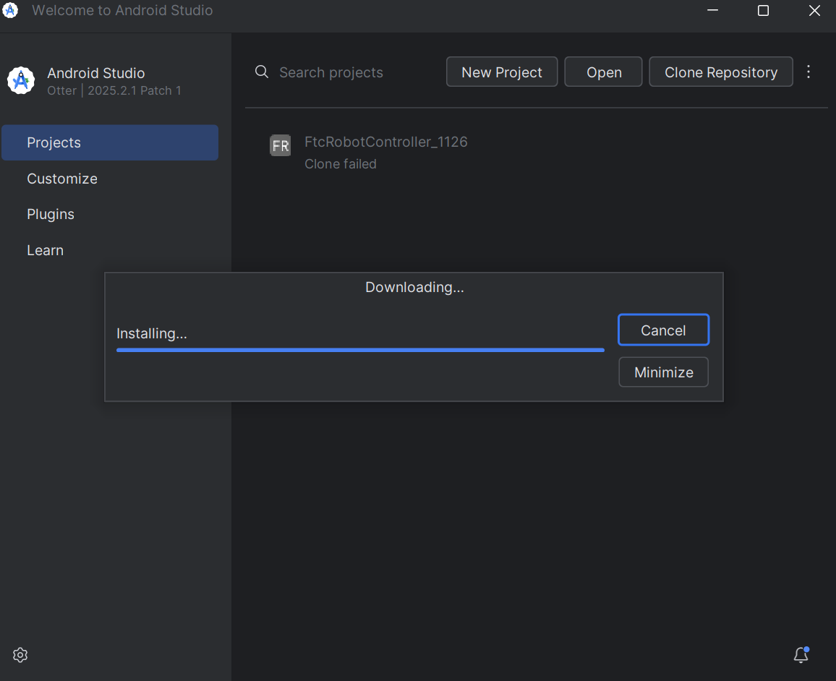

- Trust and open project
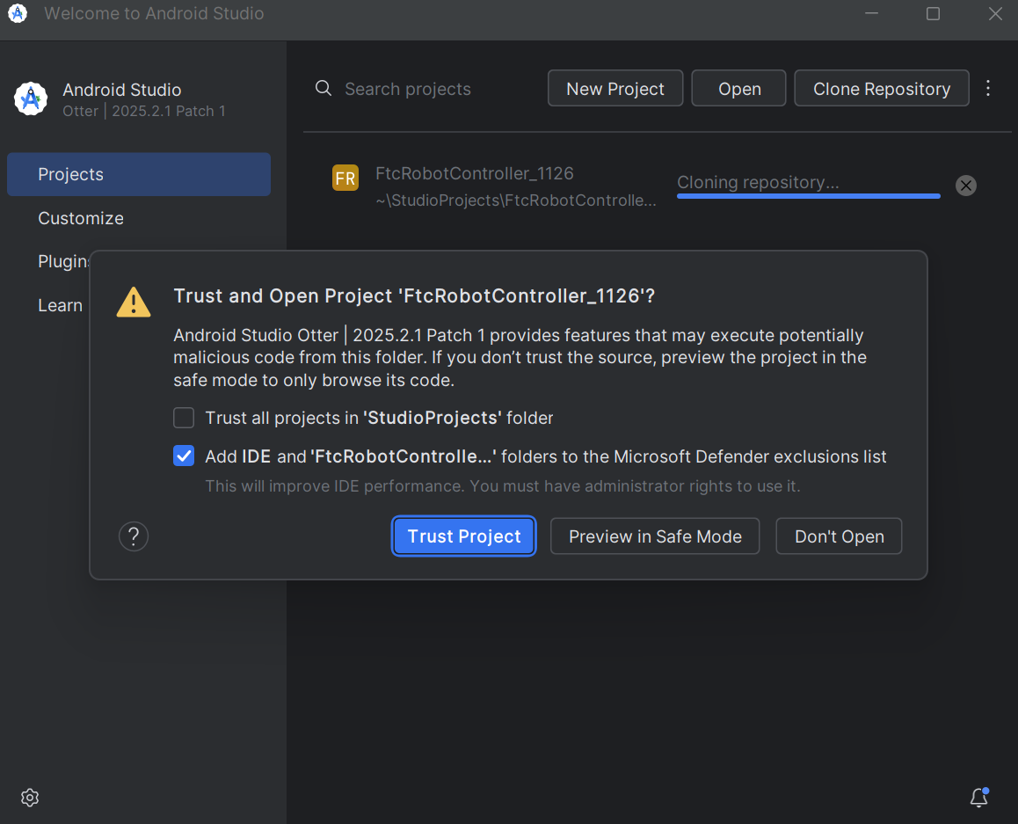

- Windows would ask, is “adb” should be allowed to connect to private network, say yes
- Android Studio would show –
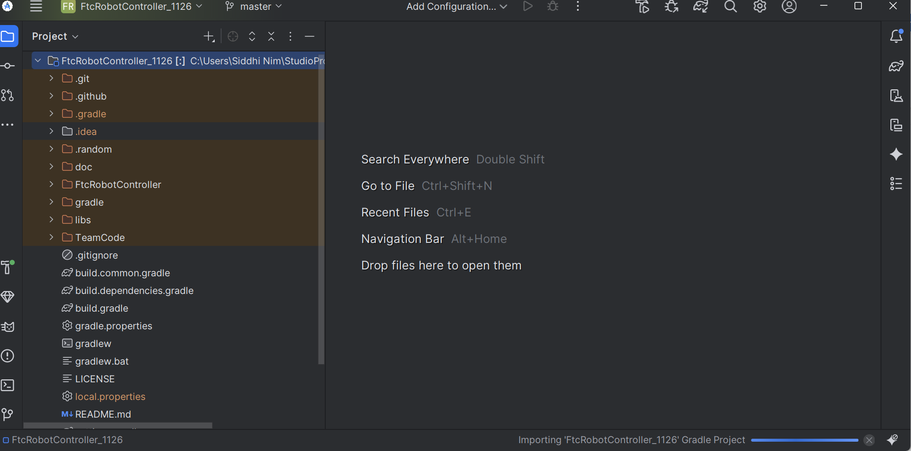

- Open the TeamCode as shown below and then open DriverTournamentFinalCode_11_24_25.java (This is the driver control program)
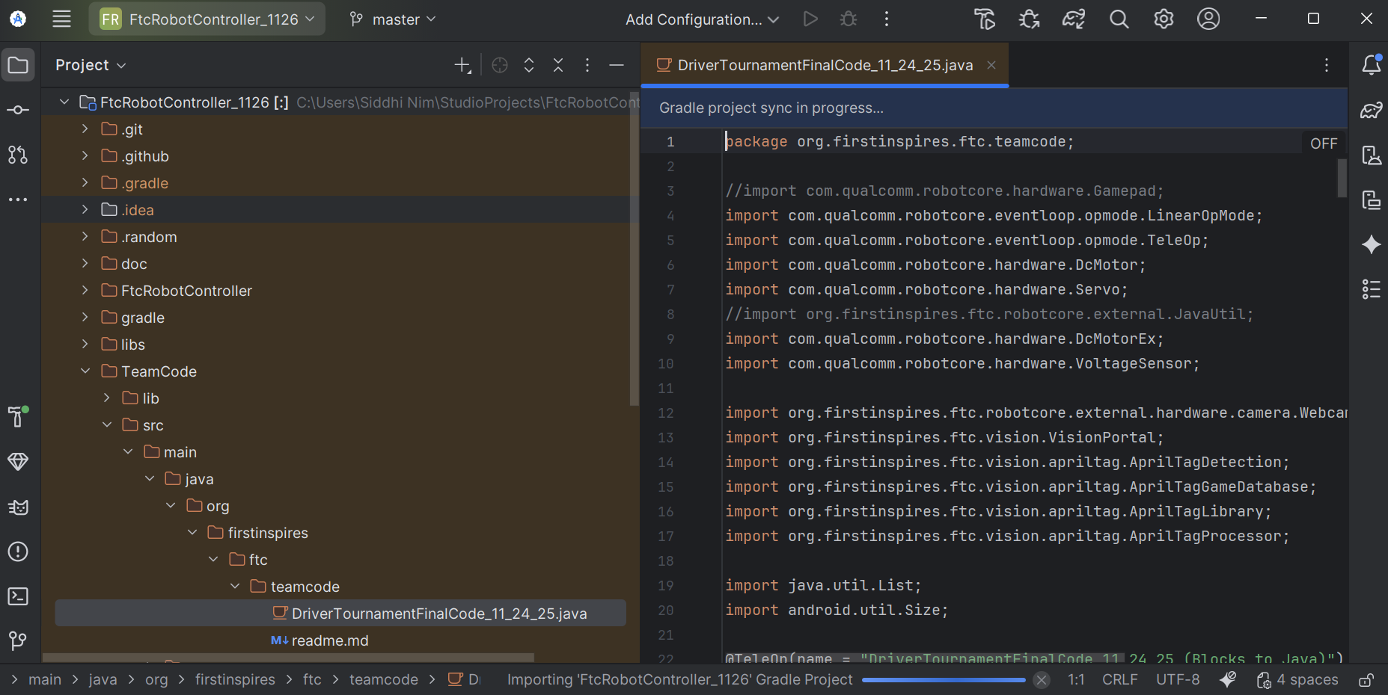
How to connect to the Robot Controller –
Option1: Connect the PC to the Robot controller with USB cable, and Andriod Studio would show “Rev Robot Controller” as target
Step 2
Step 1
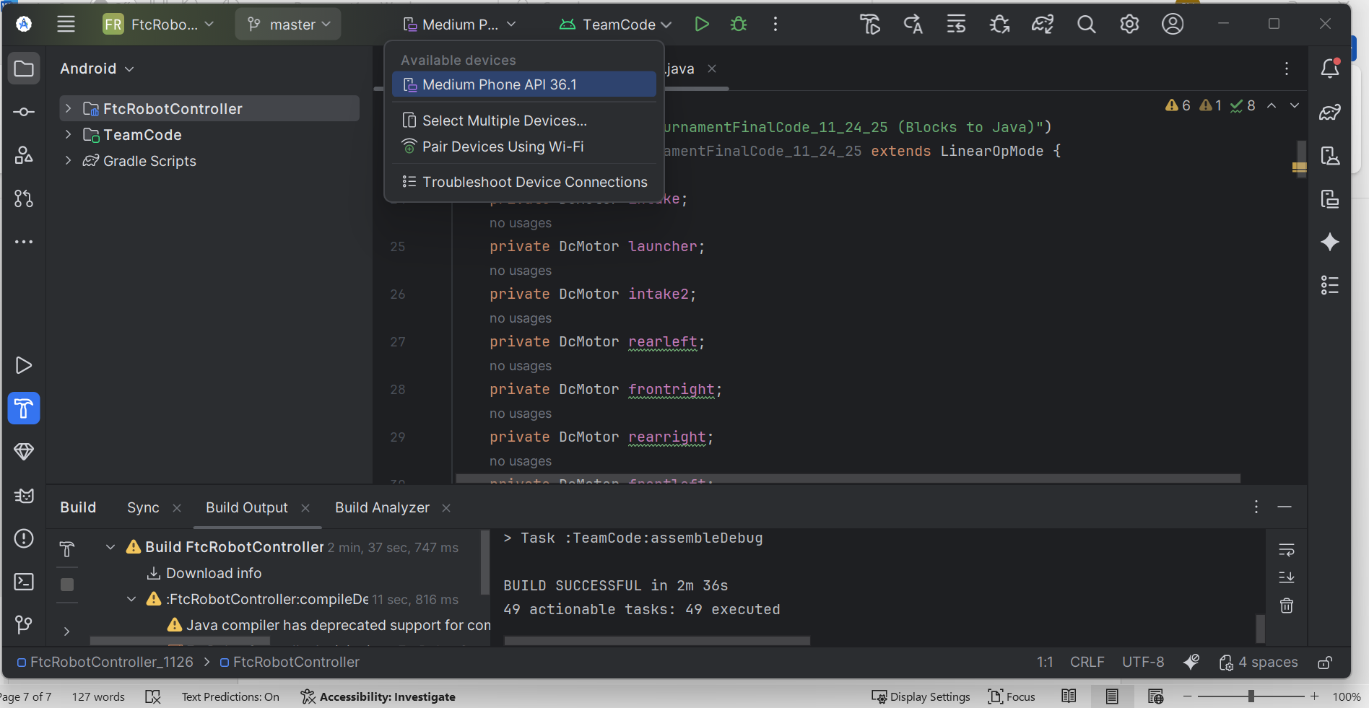

Step 1 is select the Rev Robot Controller as target, and Step2 is build and download project.
After Step2, the Robot controller would blink blue and then subsequently it turns to green

Option 2: Connect wirelessly
Do following for the first time ONLY
Add “C:\Users\Siddhi Nim\AppData\Local\Android\Sdk\platform-tools” in PATH environment variable

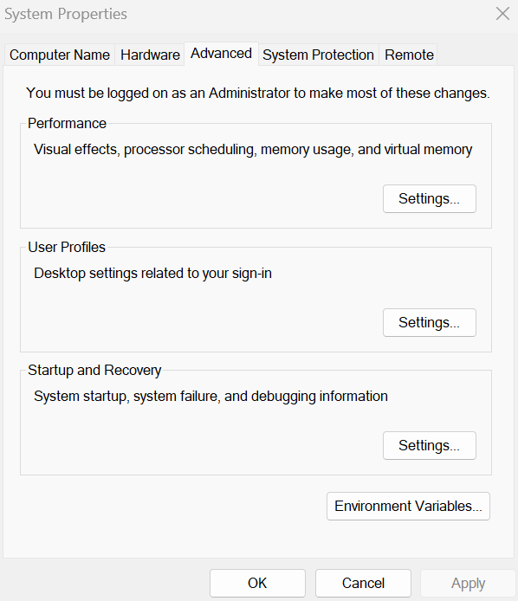

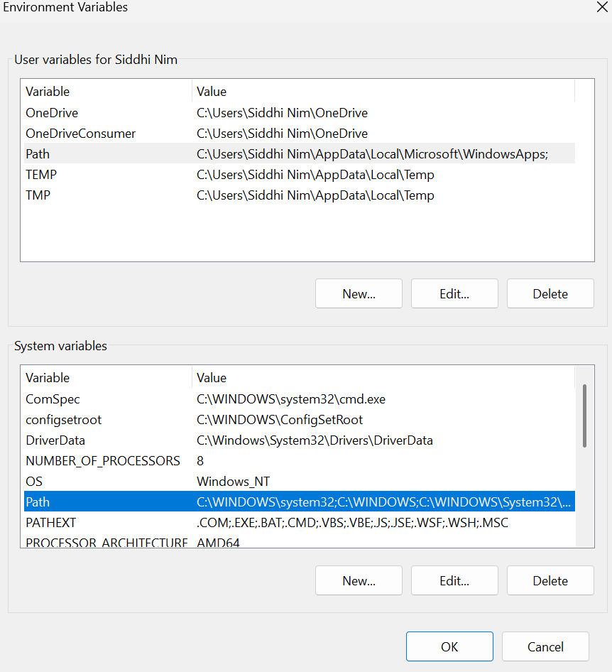
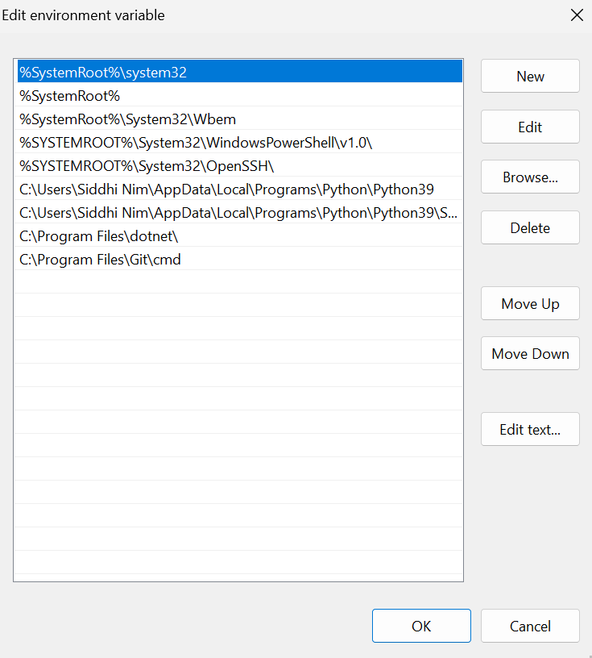
Add - C:\Users\Siddhi Nim\AppData\Local\Android\Sdk\platform-tools

Open PowerShell
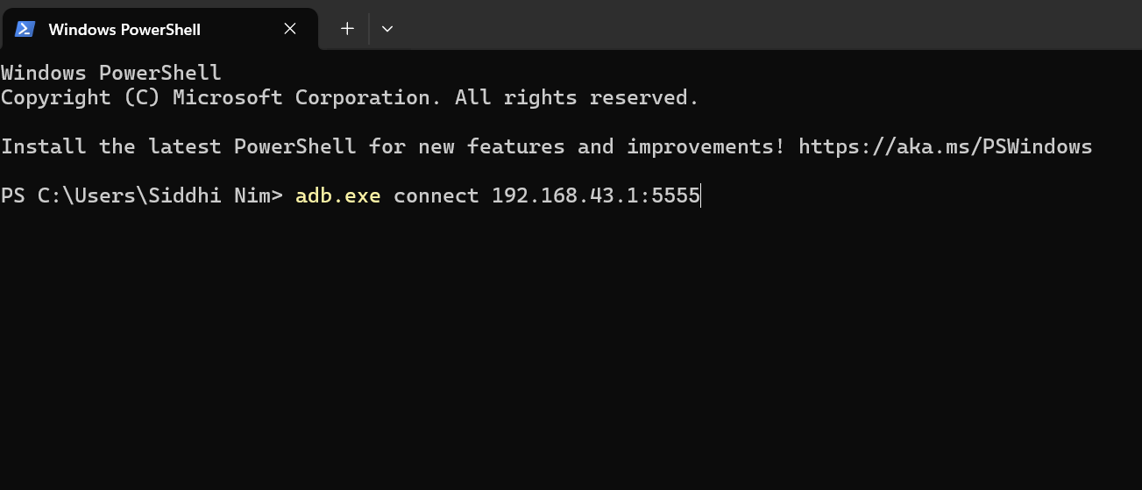
This command would connect the PC to the Robot Controller wirelessly

Andriod Studio would show “Rev Robot Controller” as target
Step 2
Step 1

Step 1 is select the Rev Robot Controller as target, and Step2 is build and download project.
After Step2, the Robot controller would blink blue and then subsequently it turns to green

How to commit the changed code back to github?
Click on the area shown above in reb box
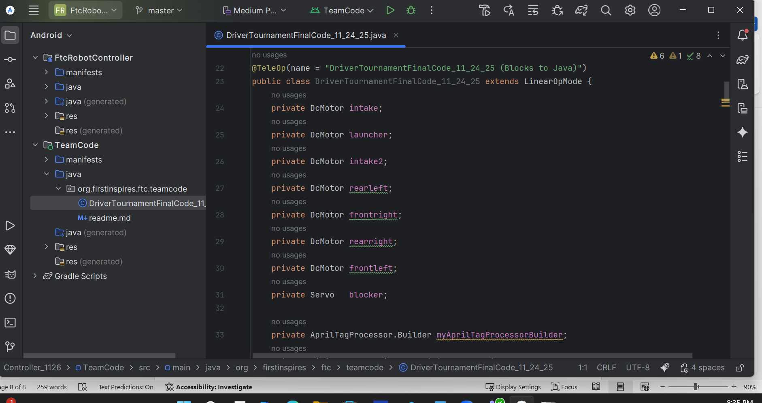
Add proper comment on what changed, and them “Commit and Push”. This would update the code on github and save it.
